Extra 8-1 Display a test scores array

In this exercise, you’ll enhance the Score Calculator form of extra exercise 4-2 so it saves the scores the user enters in an array and then lets the user display the sorted scores in a dialog box.

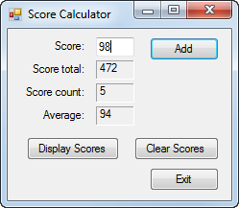 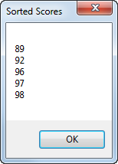

1. Open the ScoreCalculator project in the Extra Exercises\Chapter 08\ScoreCalculator With Array directory. This is the Score Calculator form from extra exercise 4-2 with data validation and exception handling added.
2. Declare a class variable for an array that can hold up to 20 scores.
3. Modify the Click event handler for the Add button so it adds the score that’s entered by the user to the next element in the array. To do that, you can use the score count variable to refer to the element.
4. Move the Clear Scores button as shown above. Then, modify the Click event handler for this button so it removes any scores that have been added to the array. The easiest way to do that is to create a new array and assign it to the array variable.
5. Add a Display Scores button that sorts the scores in the array, displays the scores in a dialog box, and moves the focus to the Score text box. Be sure that only the elements that contain scores are displayed.
6. Test the application to be sure it works correctly.